Project Overview [V1 Draft]

By Curtis Boirum 4/14/2015

This project will create a proof of concept game prototype for a 2d side scrolling action shooter where the player controls a military aircraft. The novel aspect of the game will be adding a level of realism that is very atypical of this genre of game. This proof of concept will evaluate several key features to see if they are practical to implement and if they provide or enhance a fun, engaging and possibly educational experience for the player.

The basic game design will start with the SNES game “UN Squadron” as a model to get started. New/different game design will be implemented off of this model and may deviate substantially. This is the basic game design used in UN Squadron: an overworld map with target locations that can be chosen. The target area is a “level” that consists of waves of minor enemies followed by a boss. After level select, a plane can be selected from those purchased, followed by selecting/buying weapons available for that plane. Money/resources are awarded for every kill in a level. Dying in level returns you to the overworld map. Lives are very limited and dying is very costly.

# Primary Game Concepts

Aircraft component based damage model – damaged systems affect gameplay and require strategic player choices. Could be enhanced by component crafting/ownership to add importance and consequence.

Particle system based object/terrain deformation – weapon/vehicle impacts affect whatever they hit based on small, momentary particle simulations that determine penetration, component damage, shrapnel, object segmentation, etc. Estimated as being awesome source of procedural/secondary effects like ground damage, nearby plane damage, complex damaged induced behavior/failures.

Presenting modern aircraft “realistically” – create a sense of scale among aircraft/vehicles, weapons, buildings, people, explosions, speed, altitude. Sometimes real life is more interesting than a caricature. Of course sometimes things have to be exaggerated to make an experience fun & engaging.

“Bullet time” sequences – perhaps when a weapon trajectory is precalculated as a critical hit, the weapon travel/impact is shown zoomed in super slow motion to highlight the particle system and realistic damage. This could also happen when the player is hit/crashes. Near misses could also allow the player time to react in slow motion. Also could be a great source of cinematic material.

Pseudo-random situations that require strategic player decisions – such as retreating, ditching, ejecting, flying stealthily, flying fast, flying high, etc. all with tradeoffs. Things like storms, subsystem failures, etc.

Exciting non-combat flight missions – perhaps related to constructing defenses, earning money/resources, finding upgrades or new areas, or supplying villages/allies.

# Secondary (Experimental) Game Concepts/Stretch Goals

Flight path choice – choosing a path on a heightmap of the area to visit/avoid enemies/areas. The “slice” of the hieghtmap becomes the “level”.

Interactive “bullet time” sequences – perhaps special weapons that can be controlled in flight, perhaps player assumes the role of a high speed computer controller or modified human character with hyper speed vision/response abilities. Steerable bullet, missile, **steerable lightning cannon ☺, player controlled time delayed fuse on bunker buster/armor piercing rounds.**

2.5d gameplay environment similar to “Little Big Planet” – possibility of dodging, limited maneuvering, target choice, …

Precision enemy targeting and collateral damage – avoiding destroying non-combat structures that may be significant to the player or game as a whole, requires strategic thinking to be successful.

Low enemy count fighting – more like 1 on 1 standoffs or very powerful single enemies that require strategy to overcome.

Realistic ineffectiveness of modern weapons: air to air missiles miss A LOT, weapons malfunction often, there is some interesting territory that could be explored by treating weapons as risky to use instead of mindless button presses that have no consequence. Care must be taken not to make this extremely boring though.

Mouse AND keyboard based maneuvering – aim/pitch aircraft with mouse for more realistic and free roaming movement. May complicate the experience too much – experimentation needed. Would add more possibilities for impact types & add dogfighting. Example game: [LUFTRAUSERS](https://www.youtube.com/watch?v=cmv5ZiMQWt0)

# Game Structure Inspirations:

## UN Squadron aka Area 88 (Super Nintendo Entertainment System and Anime/Manga)

Basic game mechanics & platform

Pixelated graphics that imply more than they show

nonlinear level choices,

multiple player characters, player vehicles, and weapon choices

huge, multiple destructible parts, ridiculous bosses

hard consequences for strategy choice – game can become more or less unwinnable

limited resources – choice to spend now for quick gain or save for much larger later gain

death has consequences – not as hard as some of today’s games, but everything stops when you die

great looking and somewhat realistic death animation

Fighting a superior enemy, large numbers, little hope

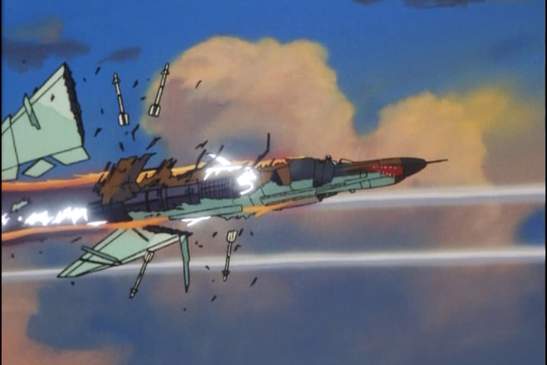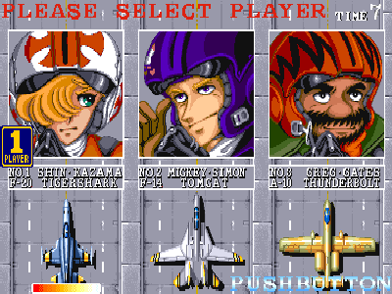

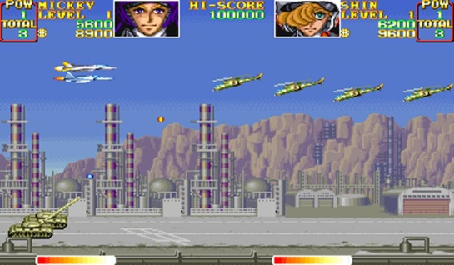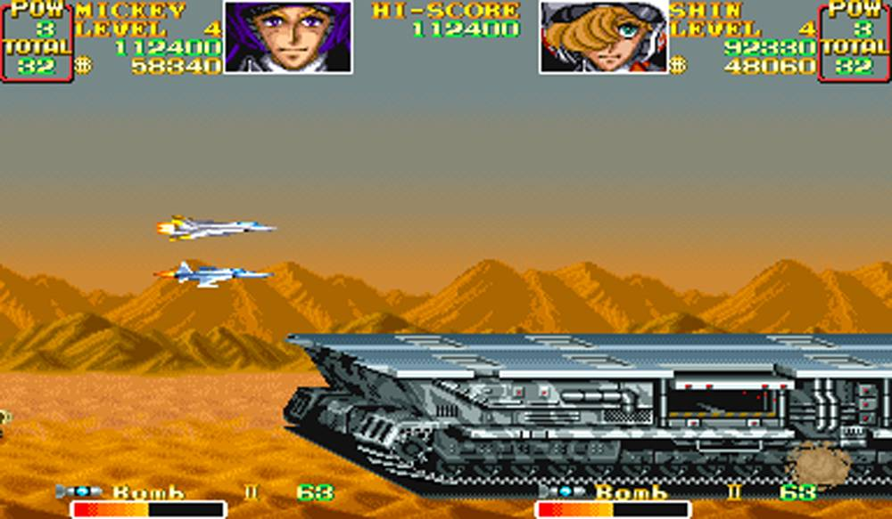

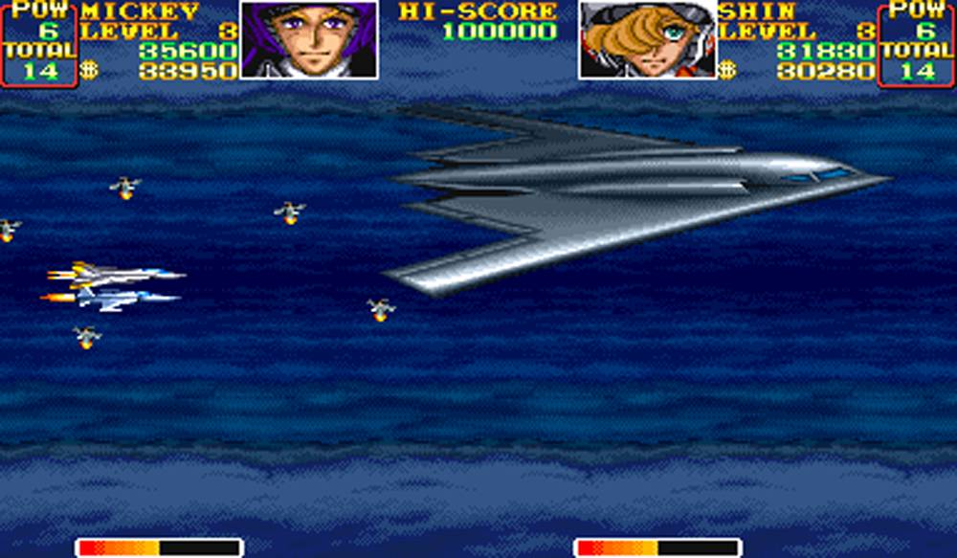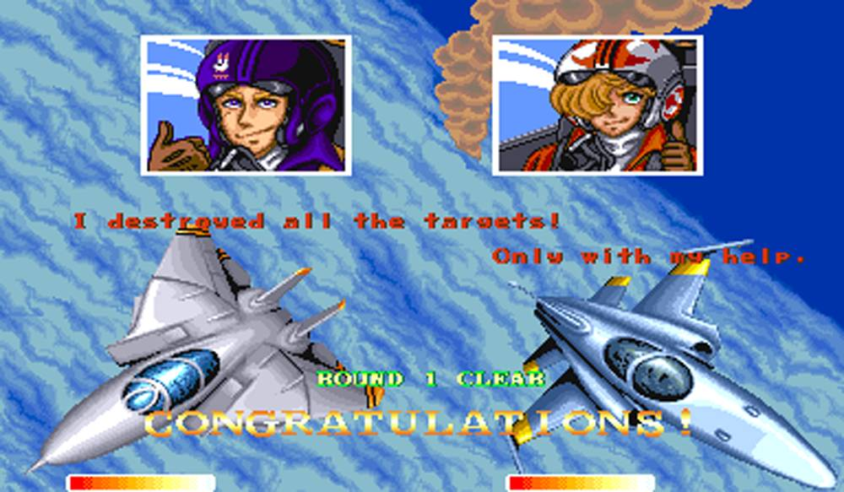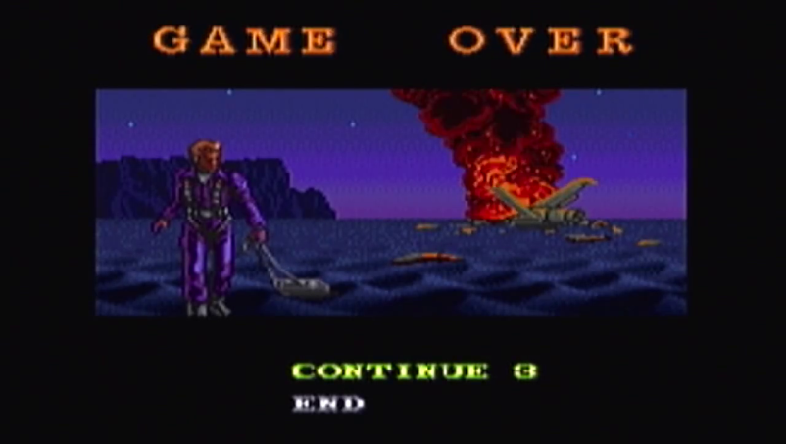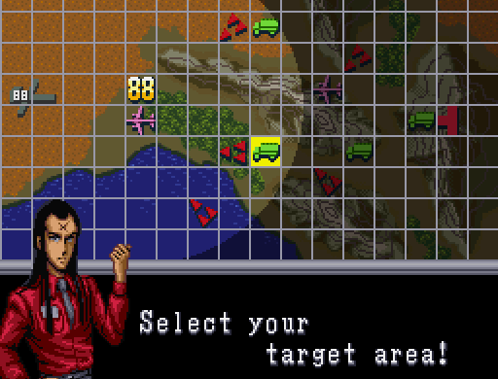

## Terraria/Minecraft/Space Engineers

Creative design and construction/building & Possible to invest in improving home/transportation routes/ safety/ defenses/ vehicles

freedom of choice

motivation to explore to find things that change the game’s experience

Creativity is rewarded by exploring options in gameplay

Open ended experience creates a meta-game (game within a game) that is fun to play for your own goals (like GTA) outside of the games predefined notions of winning or losing.

## Day-Z

Tension – long periods between action. Death can come suddenly and unexpectedly even for the well prepared. Fighting is clumsy and difficult. Things happen randomly and unpredictably and strategies must change and adapt or you will die. The decision to fire a weapon comes with many consequences – if you ignore them, you are dead or maimed quickly.

## 2D Low resolution (pixelated) games that focus on advance mechanics

Graphics are secondary to the experience. There is an almost tangible “feel” of what is happening in the game, and the gameplay mechanics

dude vs. zombies, bridge construction set, bad piggies & angry birds, scorched earth

# Gameplay Physics/Mechanics Inspirations

## World War II Online damage system

Based on penetration of ballistic objects of different densities/speeds/trajectories into vehicle plating that is at different angles and thicknesses. Damage is actually subsystems of vehicles being destroyed such as: radiator, transmission, driver, engine, turret traverse mechanism, left wing, hydraulics, etc.

[Link to video shown in screenshot below:](https://www.youtube.com/watch?v=BzpUVtVUBTI)

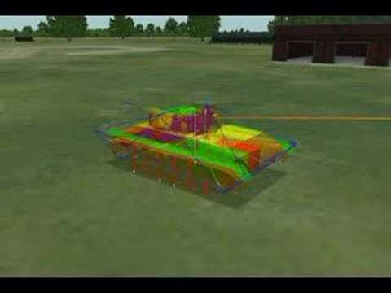

## Digital Molecular Matter

Real-time Finite Element Analysis (FEA) used to simulate flexible objects that are capable of elastic (temporary) and plastic (permanent) deformation, as well as brittle (shattering/cracking) and ductile (bending till breaking) fracturing.

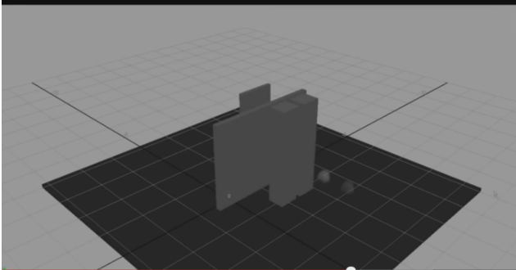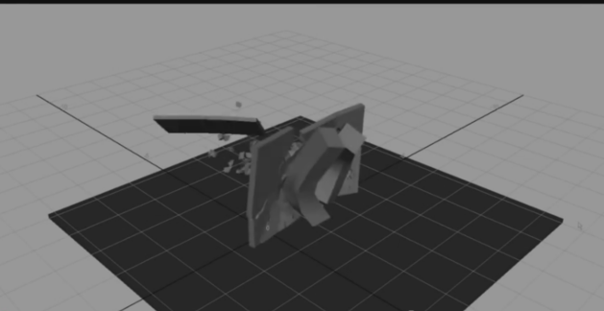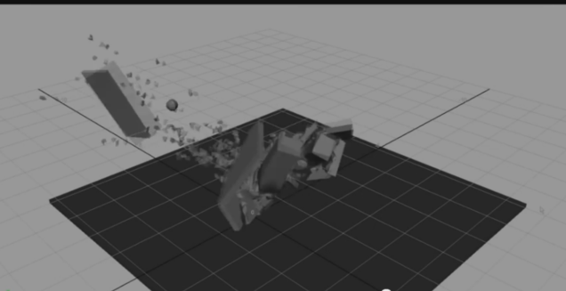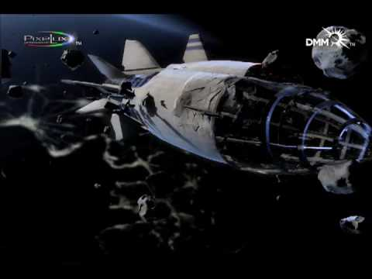

## Red Faction Guerilla

Simplified destruction model that was highly convincing and very fun to experiment with. Combat situations were highly dynamic depending on surrounding destruction, but were too “arcady”. Buildings/structures subdivided into chunks when damaged and could collapse. No bending, but a lot of planar objects subdividing into chunks and causing secondary damage. Explosion shrapnel (relatively large human size and greater pieces) could cause significant damage to surrounding structures, vehicles, and people. Highly underutilized for dramatic effect in the game, and only used as a passive side effect of player destructive action. Vehicle damage model and driving model were terrible.

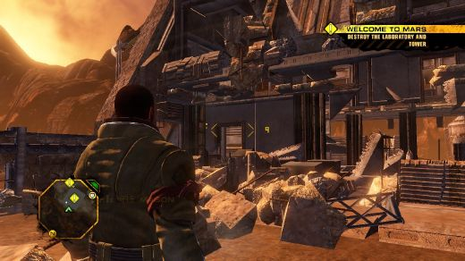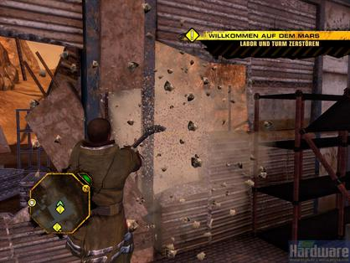 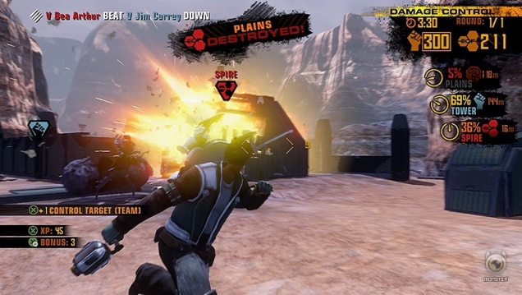 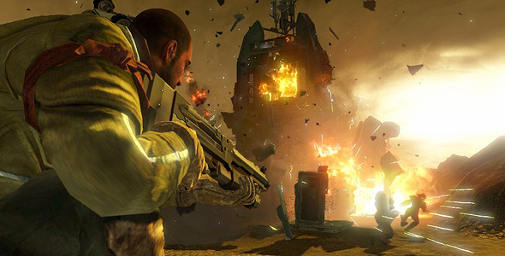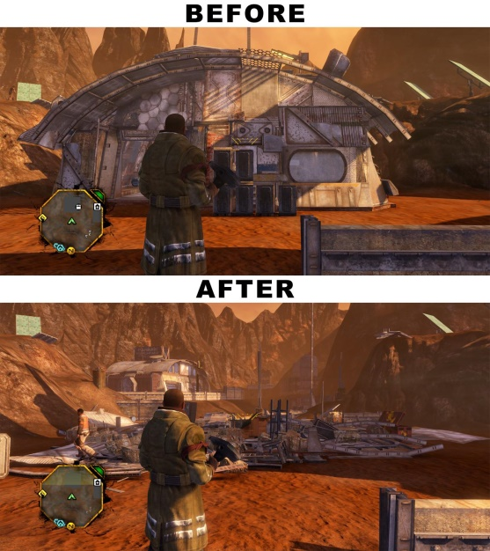

# Philosophical Influences

## All Along The Western Front (1920’s Film)

War sucks, death can be meaningless and random. There is no glory in killing, or war. Weapons and violence should never be used except as the last final resort. Collateral damage is serious and leaves a painful legacy.

## Tailspin (80’s cartoon)

Non-combat flying can be fun. Humor, relationships and humanity (even though all characters are animals). Nonviolent uses for high performance flight. Gaining a sense of tangible freedom from the ability to fly.

# Realism of Visuals Reference (very incomplete):

## Aircraft Destruction:

[F4 phantom rocket sled into cement wall test](https://www.youtube.com/watch?v=AB4IEa7jTJw)

[F4 explodes (fully fueled) into desert floor, also shows a lot of miscellaneous wreckage. Good references but silly narrated 1950’s style training video.](https://www.youtube.com/watch?v=Aa1Ba_NEobs%20)

B-52 (fully fueled) crashing from pilot error in low altitude turn.

## Emergency Landings:

[B1 B Lancer in dry lake bed](https://www.youtube.com/watch?v=XmZC5uaw69s)

## Weapon performance:

Bunker buster penetrating armored aircraft storage

# Aesthetic Inspirations

## Sniper V2

Random “kill shots” that show slow motion simulation of projectile firing, hitting, and destroying a target’s specific vital organs in people (don’t want to simulate people but want to simulate effects of damaging vital components in machines).

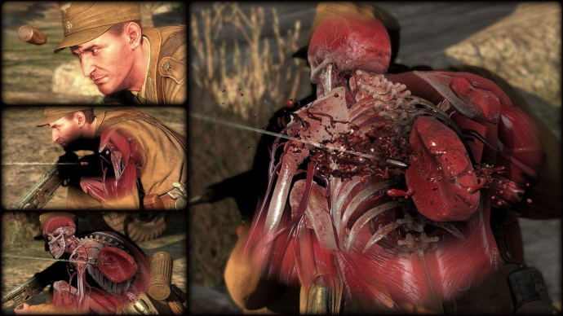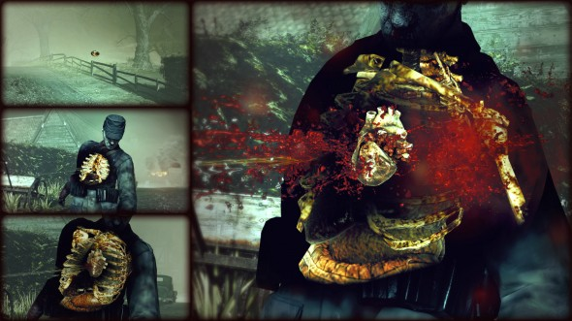

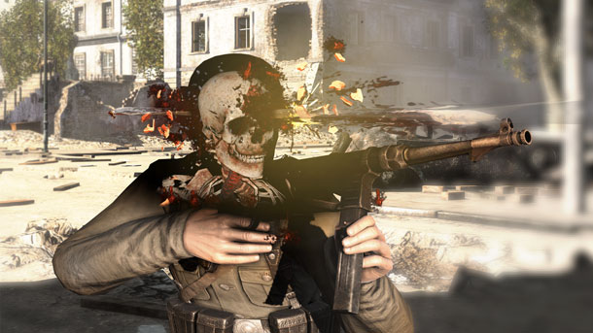

## Matrix slow motion scenes

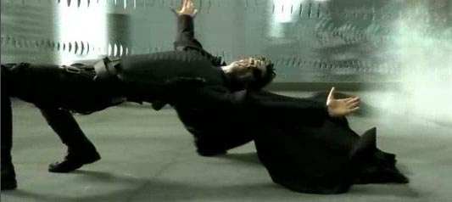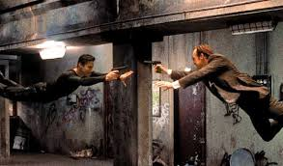

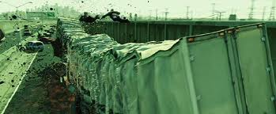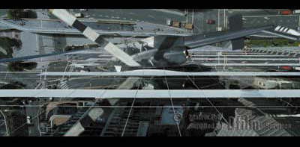

## Fight Club opening credits

Flythrough rendering of seldom seen complex microscopic process relevant to the opening situation (shows main character fear neurons in brain firing electrochemical signals that trigger sweat and then travels down the top slider of the handgun that is in the main character’s mouth.)

<http://www.dailymotion.com/video/xnj8j7_fight-club-titles-sequence_shortfilms>

 

## Fast and the Furious – “tracing air fuel mixture through engine system scene”

<https://www.youtube.com/watch?v=d2jzap-pEfQ>

